A – Basic Mass Scheduling Steps
- Collect and enter course requests
- Print reports (tally, conflict matrix, reverse verification listing)
- Build and enter scheduling master schedule
- Print scheduling master schedule reports
- Schedule students
- Print scheduling analysis reports
- Repeat as needed

B – Aeries Scheduling Tables
- SEC/MST – current schedule, impacting attendance (ATT), course attendance (CAR), grades (GRD), etc.
  - SEC table contains student numbers and section numbers
  - MST defines section numbers in SEC using CRS and STF
  - Tables work in conjunction
  - MST – you cannot make changes to MST (impacts ATT and GRD) – you can add new sections as needed, but cannot change existing sections
- SSS/SMS
  - SSS – holds student requests/section #s
  - SMS defines section numbers in SSS using CRS and STF tables – this is your sandbox, can be changed as much as needed
  - MST and SMS are identical (same fields, pull from CRS) – MST is LIVE, SMS is SANDBOX

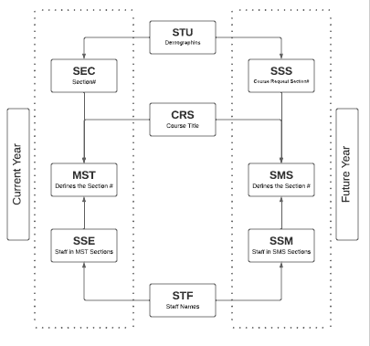

C – Forms Affecting Scheduling
- School Options (LOC table)
  - Grade Range
  - School Type
  - Schedule Basis – trimester vs. semester
- Staff Data (STF table)
  - The STF table is district owned
  - Verify Staff record
  - View MST/SMS sections
  - Placeholder Staff – no SEID – no state reporting
- Course Data (CRS table)
  - Note that Course table is district owned – field data should not be changed unless accurate for all schools using courses
  - Course (CRS) fields impacting scheduling
    - Grade Range
    - Default Credit
    - Status Tag
    - Next Year Status Tag
    - Subject Area/Department
    - T/A Checkbox
    - Fields that will show in Student Portal
      - College Prep
      - Course Description
      - CSU and UC areas
  - Other Tab - Alternate Crs – informational only
  - Prerequisite – applies in certain circumstances

D – Scheduling Dashboard
Node: Scheduling Process | Scheduling Process Dashboard
- A. Setup/Config
- B. Course Requests
- C. Build Scheduling Master Schedule
- D. Schedule Students
- E. Finalize
- F. Active Master Schedule

E – Student Scheduling Setup
Node: Scheduling Process | Configurations | Scheduling Setup
- Requires “Administer” level permission to SSS/SMS table to initialize

- Setup options
  - Status
  - Scheduling Options
  - SSS and SMS Initialization
    - Course Requests
    - Scheduling Master Schedule

F – Backup/Restore Function
Node: Scheduling Process | Functions | Backup and Restore Scheduling Results
- Backup frequently
  - At each milestone (i.e., all course requests entered, singletons placed, doubles placed, each section move)
- Restore CAREFULLY from previous versions

G – Course Request Packets
Node: Scheduling Process | Configurations | Course Request Packets
- Build new packet
- CRD/CRP permission required
- Update existing packets
- Packets are school-specific
- Packets copied year to year

H – Entering Course Requests
Parent/Student Portal
- Allows parents/students to enter course requests
  - Parents/students need permission to SSS
- Update course request options (CRQ)
  - Create/Recreate Course Options
    - Pulls all ACTIVE courses from CRS table
    - Grade range is applicable
  - Modify by grade level
  - “Allow” checkbox for individual courses
  - Tag/Untag all
  - Update totals from MST – shows current enrollment numbers
  - Tag/Untag based on totals
  - Add a Course – if new course was added to CRS after table created, this can be used to pull single course in
  - Hide un-Tagged Courses
- Portal Options – Scheduling
  - For Parent/Student Portal course request entry
  - Allow Alternate Request
    - Max Number Primary/Alternate
  - Define date range for each grade level
  - Hide Scheduling Results
  - Hide Currently Scheduled Classes for Future Terms

Import Course Requests from Academic Plan
- Select Term
- Select School
- Select Grade Levels
  - Allows Query KEEP/SKIP
  - Additional Options
  - Preview/Update

Mass Change or Add Course Requests
- Discuss use of form to mass change, mass add, or mass delete
- Change students with these course requests
  - Leave blank to ADD courses only
- To now have these course requests
  - Leave blank to DROP courses only
- Course Request Packets Button
- Grade/Gender restrictions
- Allows Query KEEP/SKIP
- Preview/Update
- Print List

Individual Student
- Add One/Add Many New Record(s)
- Edit/Delete Records
- Staff Preference
- Add From Course Request Table
  - Brings up portal view
  - Only pulls allowed CRQ records
  - Can add/edit requests/alternates
- Course Request Packet
- Alternate Course Requests
  - Enter alternate requests
  - Sort by priority order
  - Use “Manage” to link alternate to primary request
- Scheduling Exclusions
- Meets – pulls from Class Calendar

I – Course Request Reports
- Scheduling Course Request Tally
  - Simple tally of student requests by grade
- Scheduling Conflict Matrix
  - List, chart of potential conflicts, especially for singletons and doubletons
- Scheduling Reverse Verification Listing
  - Listing of students requesting specific courses

J – Flex Periods
Node: Attendance Accounting | Configurations | Flex Periods
- Assign each Academic Year
- Permission to FTF, FTT, and BSD
- Short Title – 6 characters
- Tiny Title – 2 characters
- Description – long version
- Start/End Times
- Type
  - Blank – Standard Flex Periods
  - “C” Non Conflict Flex Period
    - Scheduler will not check for date/time conflicts
    - Allows student to be scheduled into section that meets at same time as another class
- Assigned to sections

K – Class Calendars
Node: Attendance Accounting | Configurations | Class Calendars
- Assign each Academic Year
- Add New Calendar – Save – Mass Select Dates
- Short Title – 6 characters
- Description – long version
- Mass Select Dates appear when adding new Class Calendar
- When logged into current school year and DAY table created, Mass Select Dates will skip any non-school days
- Admin users can COPY (within same school)
- Admin users can PUSH (to other schools)

- Recommended to have 1:1 relationship between Flex Periods and Class Calendars
- Assigned to sections

L – Build & Enter Master Schedule (SMS)
Node: Scheduling Process | Scheduling Master
- Primary SMS Section Fields
  - Section number assigned by Aeries
  - Semester
  - Flex Period
  - Class Calendar
  - Course ID
  - Tag
  - Sch Exc – no students will be added to this class with mass schedule, students can be added manuall
  - Exclude – excludes from grades, attendance, or both
  - Max number of students
- Fields defaulted from Course (CRS)
  - Credit
  - Grade Range
- Section Staff Members
  - Pulls from STF
  - Primary Teacher
  - Staff Role
  - Permissions
  - Status
  - Multiple staff members can be assigned to section
- Sections with missing Flex Period or Class Calendar will not be scheduled

M – Scheduling Master Schedule (SMS) Board
Node: Scheduling Process | Flex SMS Board
- Overview tour of SMS Board
- CAUTION: Only one person should be making changes at a time
- Display Options
- Add, Change, Move, Copy, Delete
- Schedule Students
- SMS Builder

N – Scheduling Master Schedule Reports
- Before students scheduled, validate data entry
- Prescheduling Edit Listing – potential conflicts (no sections assigned, invalid course, grade range, too many requests to be scheduled, no course requests)
- Scheduling Course Request Analysis – tally with section count, section average, and seats short info added
- Print Scheduling Master Schedule – by Course, Teacher, Room, etc

O – Schedule All Students
Node: Scheduling Process | Schedule All Students
- Options for scheduling runs
- Schedule All Students
  - Grade Level Order
  - Alpha Order
  - Additional Options
- Review results summary

P – Scheduling Master Schedule (SMS) – After Scheduling Students
- Copy sections
  - Perm Lock students will not be moved
  - Options to Move/Copy/Do Not Move or Copy students
- Move/Copy students to another class
  - Tagged Students
  - All Students
  - Use Section #0 to Drop all students from the class – Move Students
- Delete Section
  - Keep/drop course request

Q – Scheduling Analysis Reports
- Scheduling Course Request Analysis
  - Identifies how many seats short and how many rejects for each course
- Scheduling Class Load Analysis
  - Detailed statistics for all sections
- Scheduling Class Load Averages (Seat Count Report)
  - “Display only Totals” option recommended – seat counts per grade/period

R – Course Requests/Schedule
Node: Scheduling Process | Course Requests/Schedule
- Use Previous/Next Rejected Student
- Types of Rejects
  - All Full
  - Conflict
  - Grade Range
  - Teacher Preference/Exclusion conflict
  - Stu Group
  - Track
  - Sex Restriction
  - Alternate – alternate was scheduled
- Locking Sections
  - Temp lock – one/individual sections
  - Temp lock – All sections
  - PermLock Sections – Lock stays in place after roll to MST
- Reschedule button – reschedule individual student, skips any locked sections
- View SMS – display SMS sections/details
  - Sort or Limit features
  - Add section or course from View SMS

S – Grouping Features
- Semester Group (single character)
  - Ensure that one course from group will be in Fall and one course in Spring (i.e., Govt/Econ)
- Scheduling Group (max 2 characters)
  - Example – Houses or Academies
  - Students are assigned to a scheduling group, and sections are also assigned to a scheduling group
- Team Course Group (max 2 characters) & Team Number (0 - 9999)
  - Example – Core Team Teaching
  - Assign the same Team/Course group code to all sections of all courses that are to be divided into teams/groups
  - Scheduler splits the kids up into groups without having to mark each student into a specific group

T – Final Steps
- Print Student Locator Cards – choose SMS
  - Review additional options
- Print Class Rosters – choose SMS
  - Review additional options
- Copy Scheduling Results to SEC & MST
  - Requires “Administer” level permission to SEC/MST table to copy
  - Term dates defined in School Options before copying scheduling results
  - Copy to SEC/MST function will:
    - Copy SSS to SEC – will overwrite if SEC already has classes
    - Copy SMS to MST – will overwrite if MST already exists
    - Copy SSM to SSE – will overwrite if SSE already exists
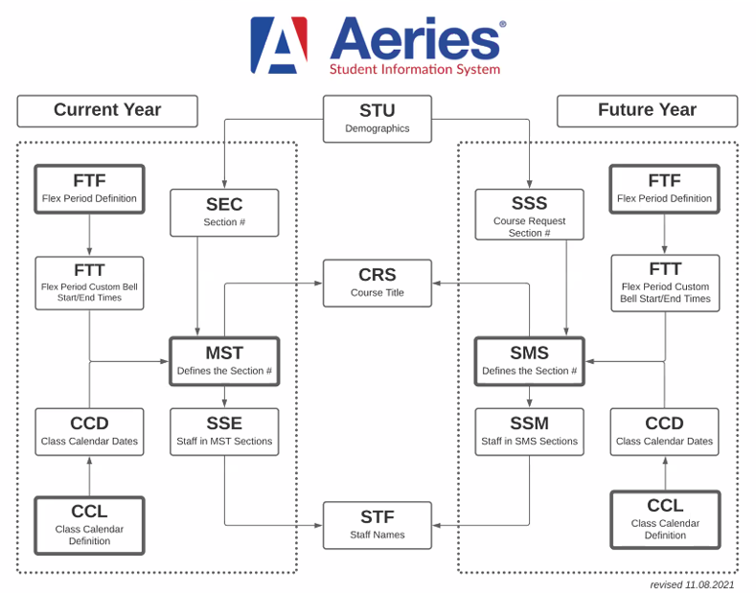

Query Samples

SSS: List of Teachers with Section Information on Teams/Groups and Grade Levels
LIST SMS SSM STF STF.FN STF.LN SMS.SE SMS.FSQ SMS.SG SMS.CG SMS.TM SMS.LO SMS.HI BY STF.FN STF.LN IF SSM.PR = 1

SSS: List of Sections with Scheduling Team/Group Designation
LIST SMS SSM STF STF.FN STF.LN SMS.SE SMS.CN SMS.FSQ SMS.SG SMS.CG SMS.TM BY STF.FN STF.LN SMS.SE IF SSM.PR = 1

SSS: List of Students with a Preferred Teacher Not Scheduled with Preferred Teacher
LIST STU SSS SMS SSM STF STU.NM SSS.SE SMS.SE SSM.ID SSS.PS IF SSS.PS # STF.ID AND SSS.PS # 0 AND SSM.PR = 1

SMS: List of Students with Teachers and Section Information for 1st Period by Teacher from Scheduling Master Schedule
LIST STU SSS SMS CRS SSM STF STU.ID STU.NM STU.GR STF.ID STF.LN STF.FN FTF.STI SMS.RM SMS.SE CRS.CO BY STF.LN STF.FN IF FTF.STI = "###" AND SSM.PR = 1
Enter Flex Short Title for first period

MST: List of Teachers and Course Information for a Specific Period
LIST MST CRS SSE STF MST.FSQ STF.ID STF.LN STF.FN MST.RM MST.SE CRS.CO BY STF.LN STF.FN SSE.PR IF MST.FSQ = "XXX" AND SSE.PR = 1
Enter Flex Short Title for period

