Repeat tag Scenarios
The purpose of this is to demonstrate, using 2 simple transcript records, the effect of using a repeat tag
Legend - CA = Credits attempted – CC = Credits Completed - GPA = count in GPA
Using No Repeat Tag
Student receives an F in a course on 1st take and a passing grade 2nd take
If No repeat tag on either course –Repeat tag field is blank = count everywhere – CA, CC, count in GPA
Outcome - GPA and Credits - CA = 10, CC = 5, GPA = 1.0
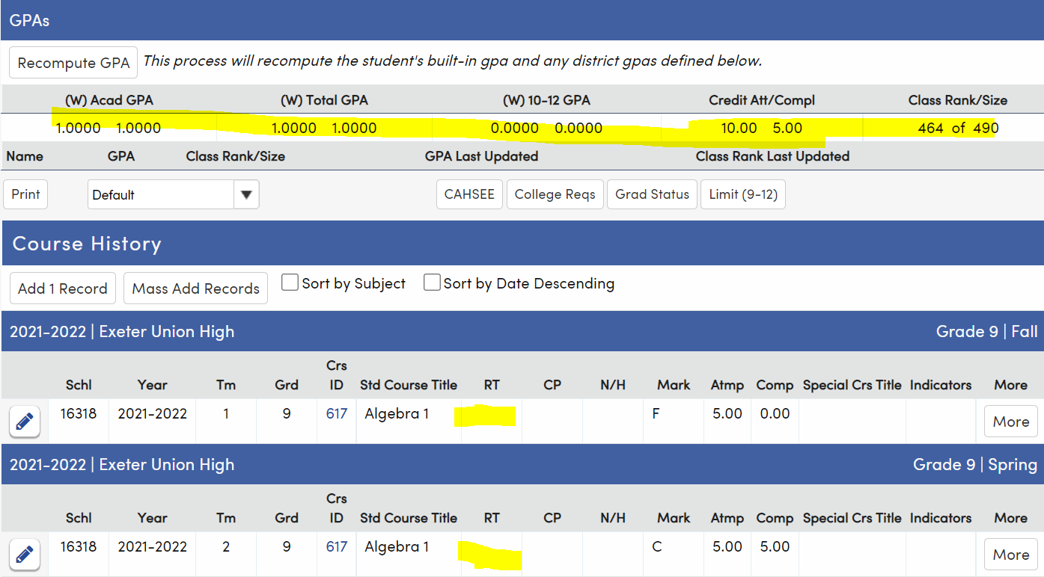
Outcome - Grad Status – 5 credits of Math Completed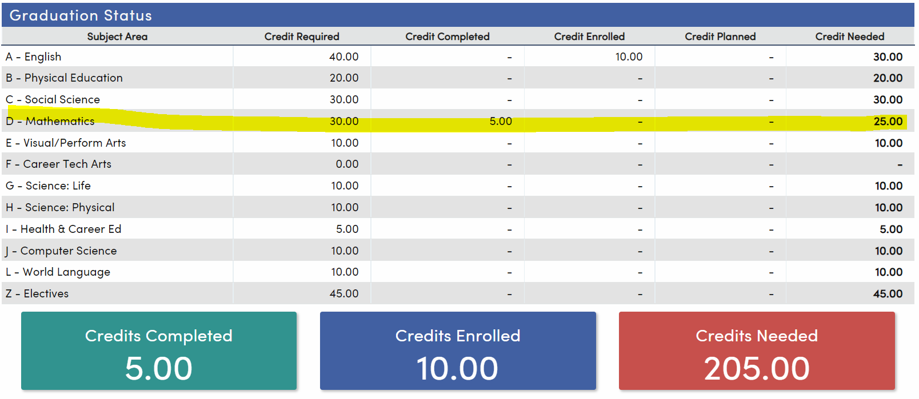

Using Repeat tag of R on 1st course

Student received an F in Algebra 1 – 1st take, and a C in Algebra 1 - 2nd take – acts just like No Repeat tag – why bother?
Repeat tag of R is applied to 1st course = CA, no CC, count in GPA
Outcome - GPA and Credits - CA = 10, CC = 5, GPA = 1.0
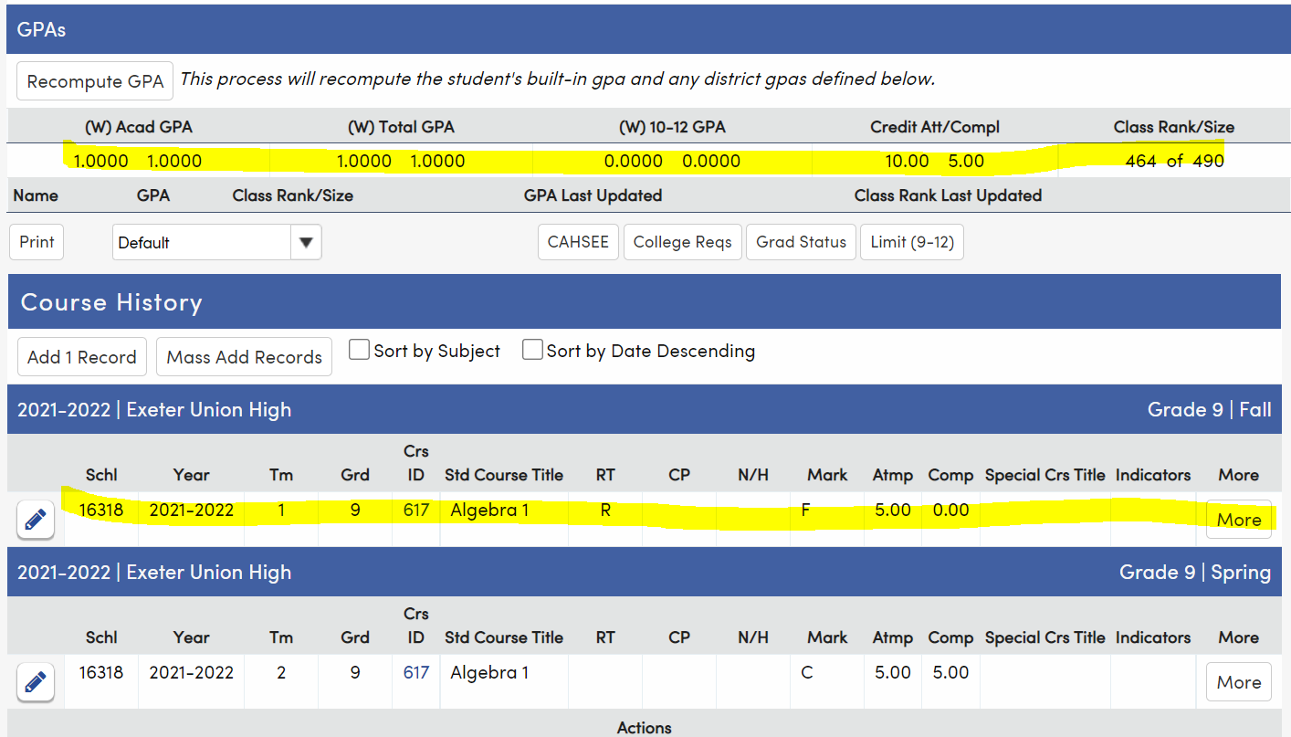

Outcome - Grad Status – 5 credits of Math Completed
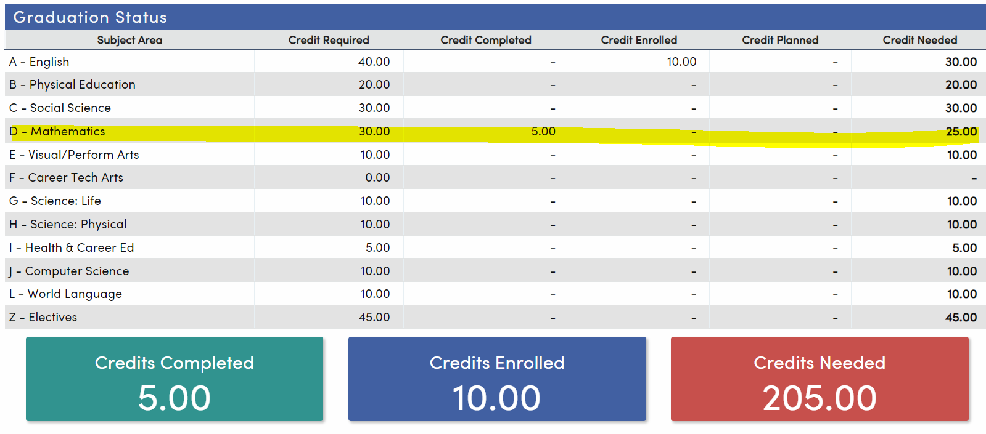

Using Repeat Tag of R on 1st course
Use when student receives passing mark the first time but wants to repeat for a better mark
Repeat R on 1st Mark - Repeat of a D, CA No CC, GPA
CA = 10, CC = 5, GPA = 1.5
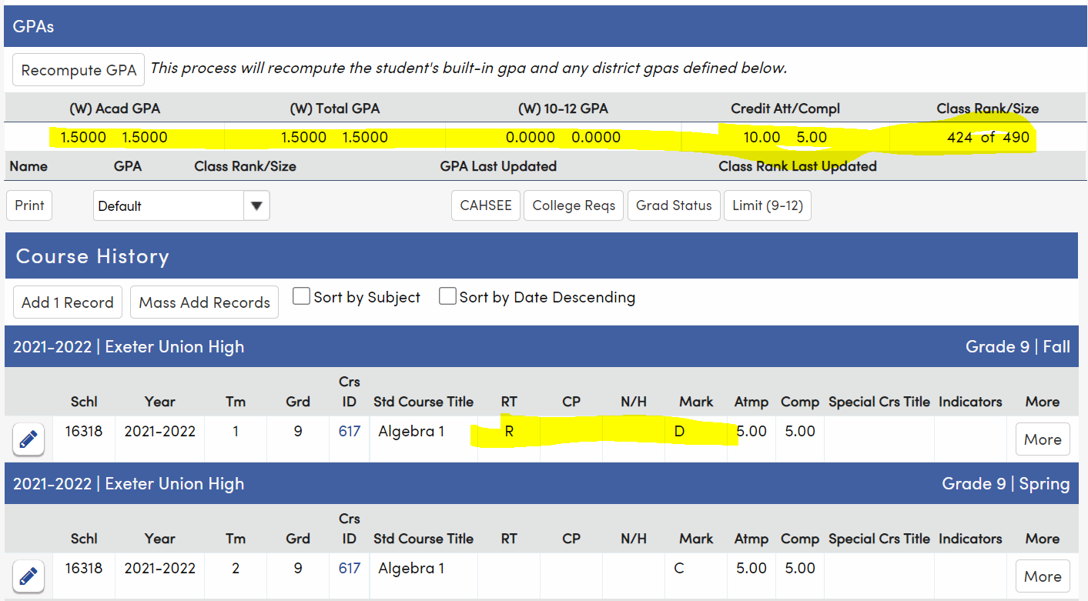

Grad Status – 5 credits of Math completed – no Math credit awarded for the D
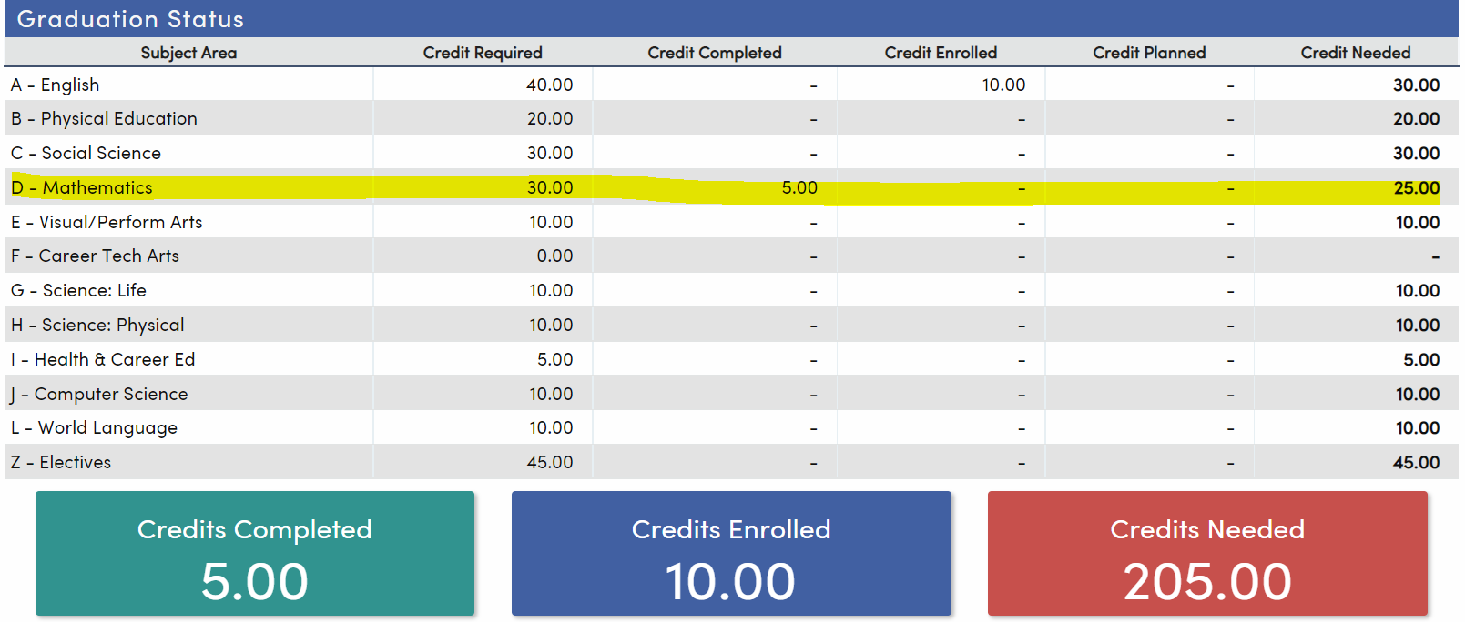

Using Repeat tag of R on 2nd course
Use when student receives lower mark on 2nd take

Student received a D in Algebra 1 - 1st take and an F in Algebra 1 - 2nd take
Repeat tag of R is applied to 2nd course = CA, no CC, count in GPA
Outcome - GPA and Credits - CA = 10, CC = 5, GPA = .5
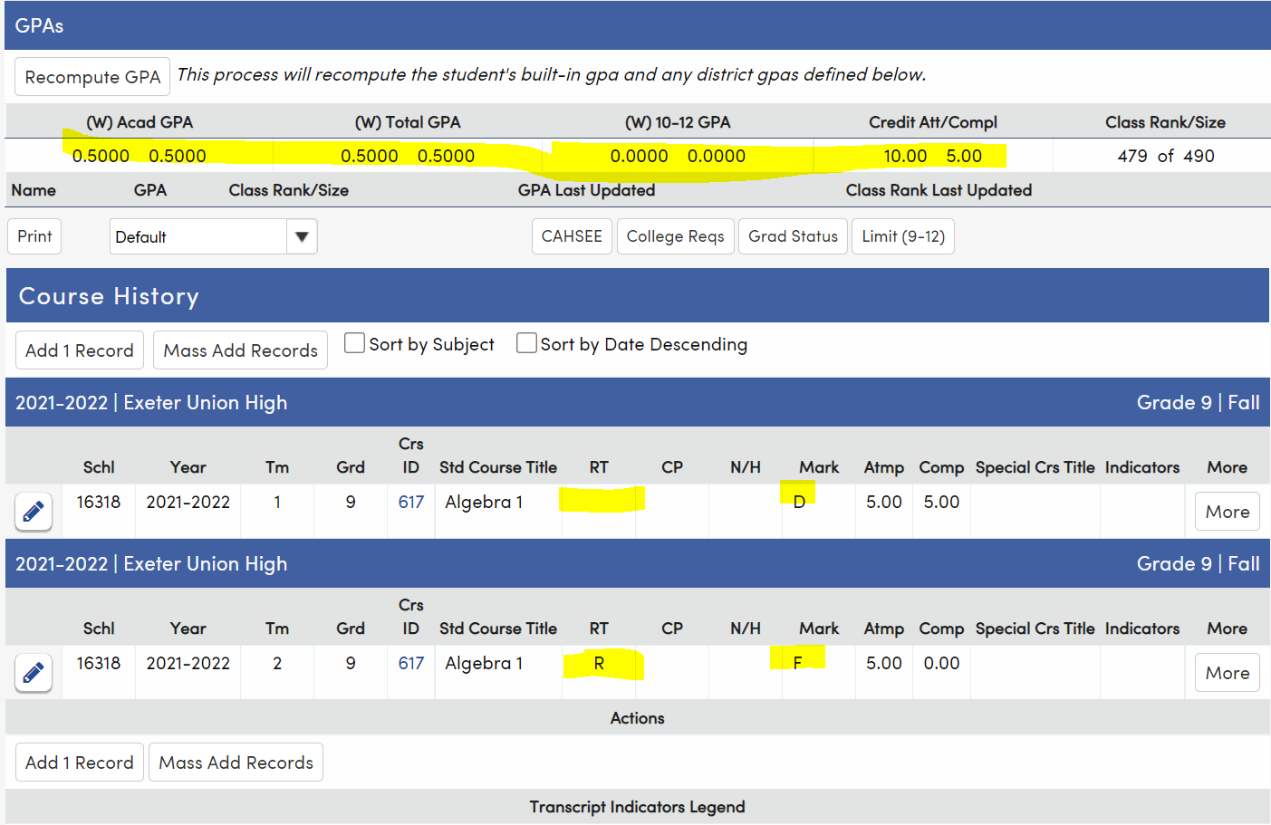
Grad Status = 5 credits of Math completed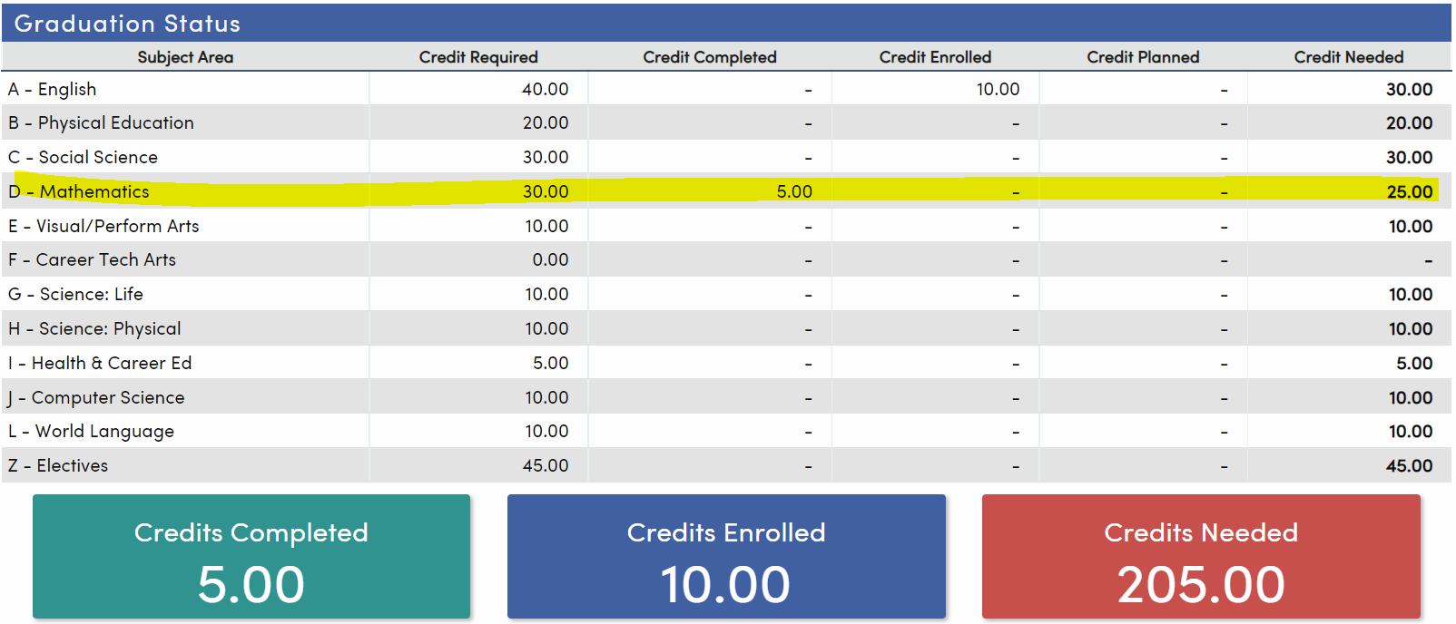
Using Repeat of N on 1st course = No CA. No CC, No GPA
Essentially removes the course and mark from calculation
Use when replacing the mark – CIF?
1st take – F, 2nd take - C
CA = 5, CC = 5, GPA = 2.0
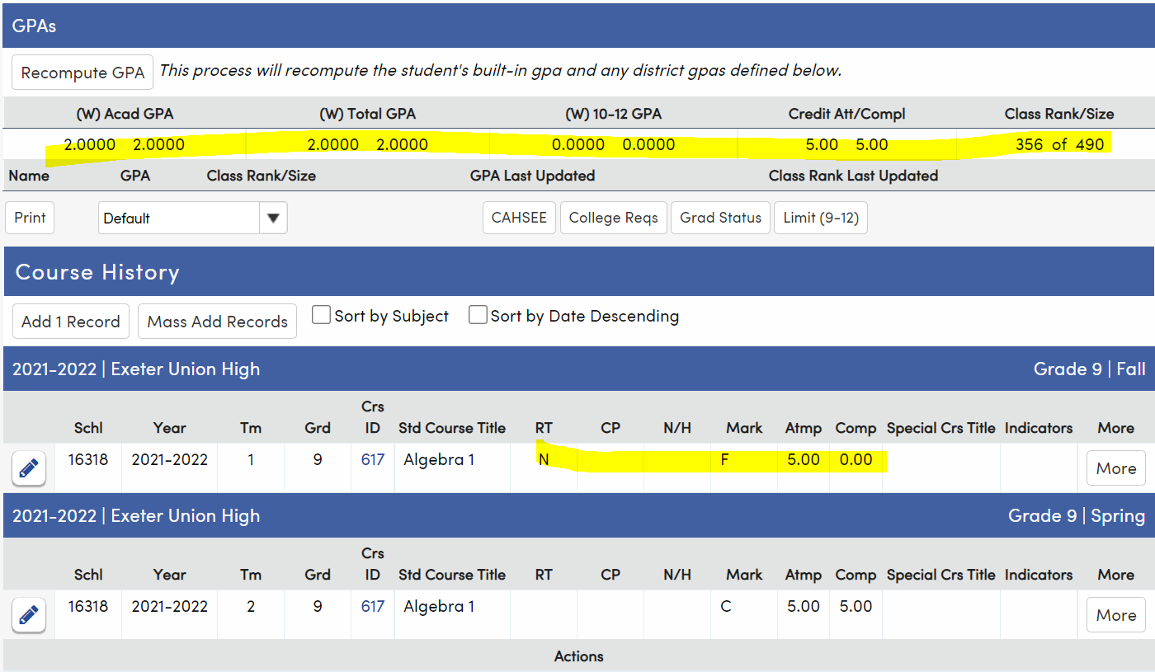

Grad Status = 5 credits of Math Completed
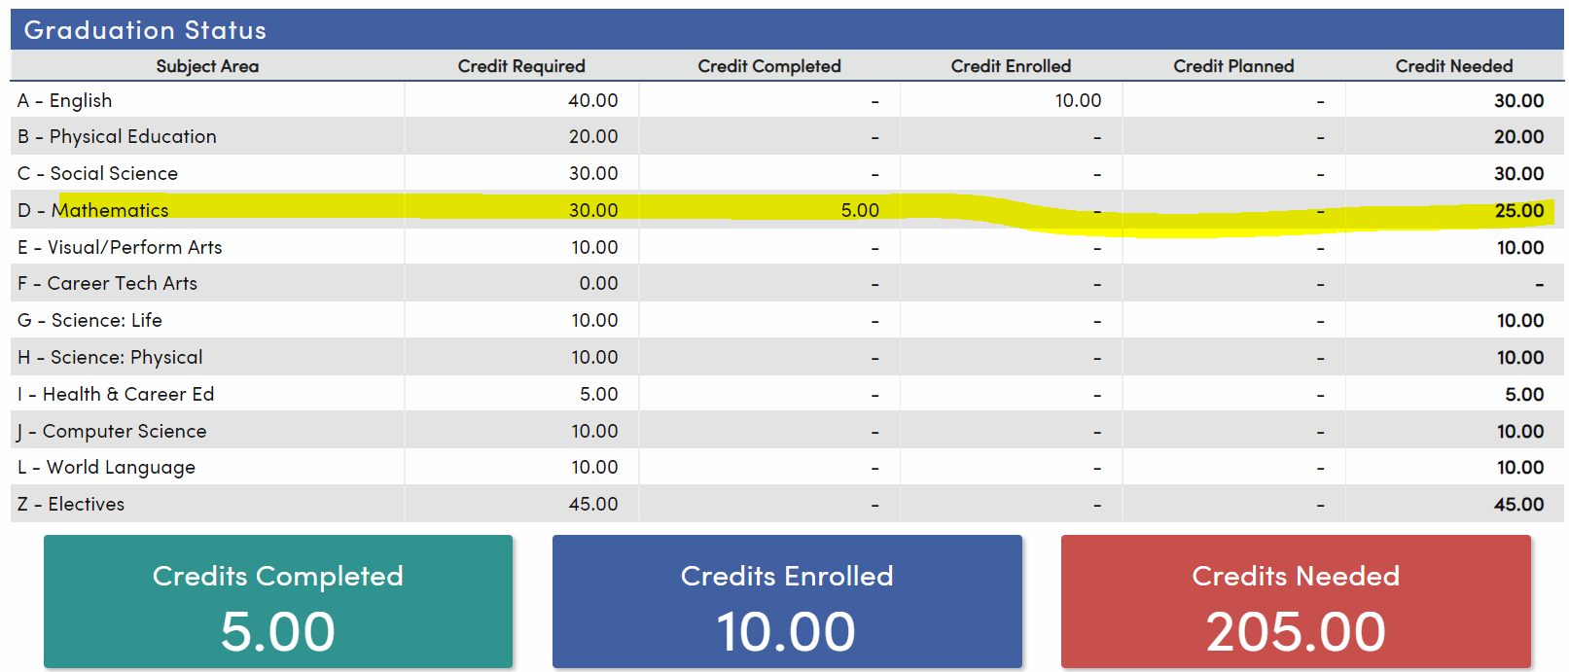

Using Repeat of N – 2nd Course - No CA, NO CC, No GPA
Use when student receives lower mark on the 2nd take and you want to remove the course and mark from the calculation
CA = 5, CC = 5, 0.00 – GPA = 1.0
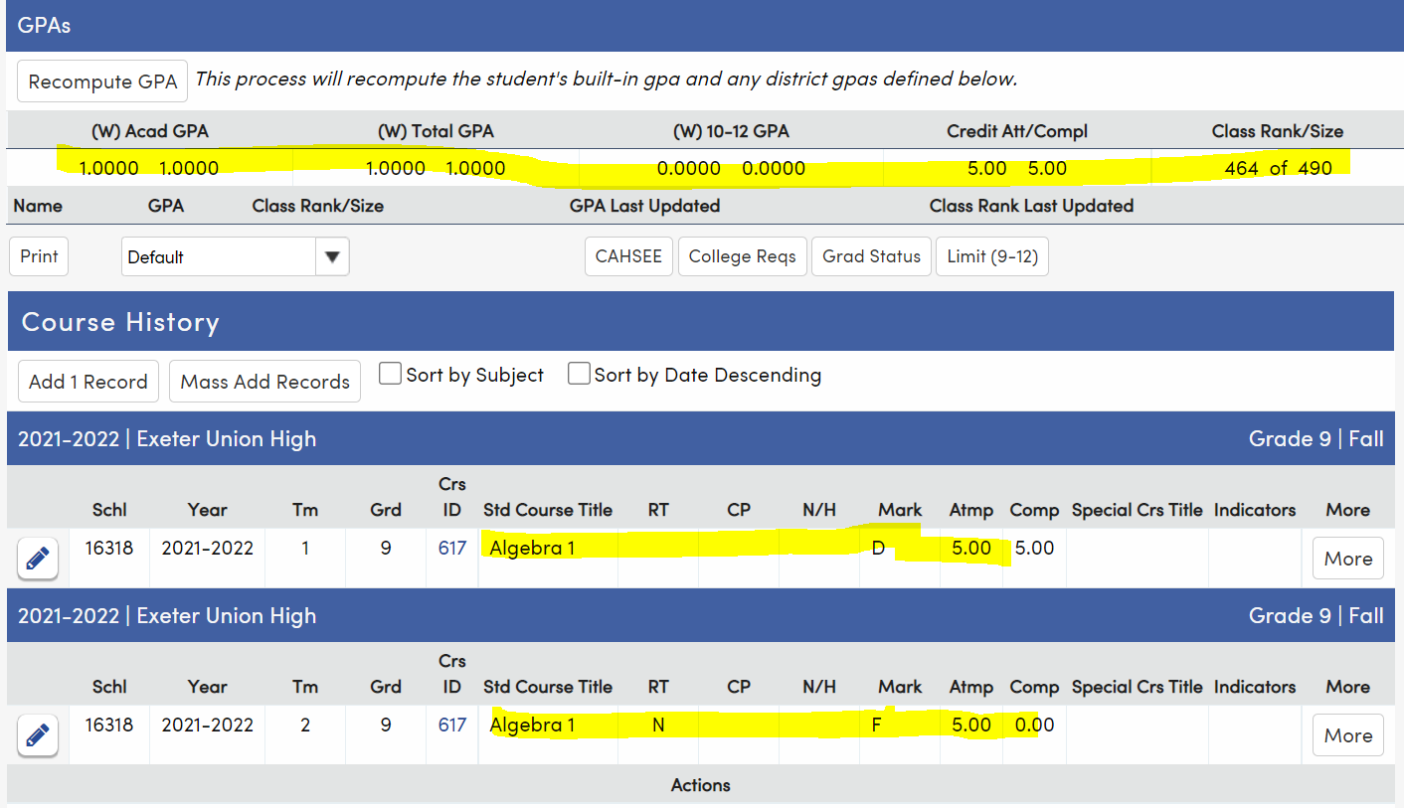
Grad Status = No credits of Math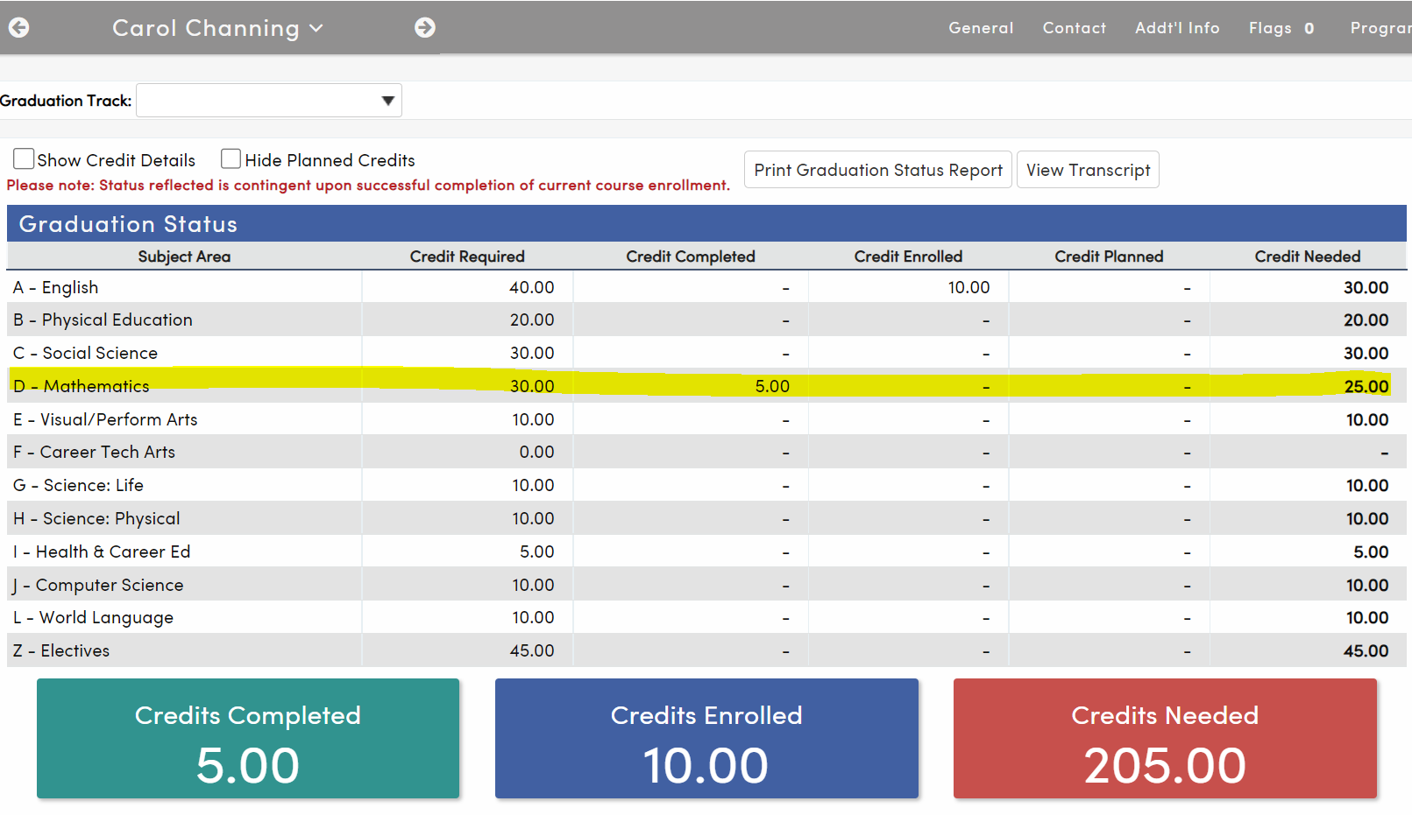
Using Repeat tag of B 1st Course – CA, CC, No GPA
Removes the mark from the GPA calculation but counts in CA and CC
Use?
CA = 10, CC = 5, GPA = 2.0
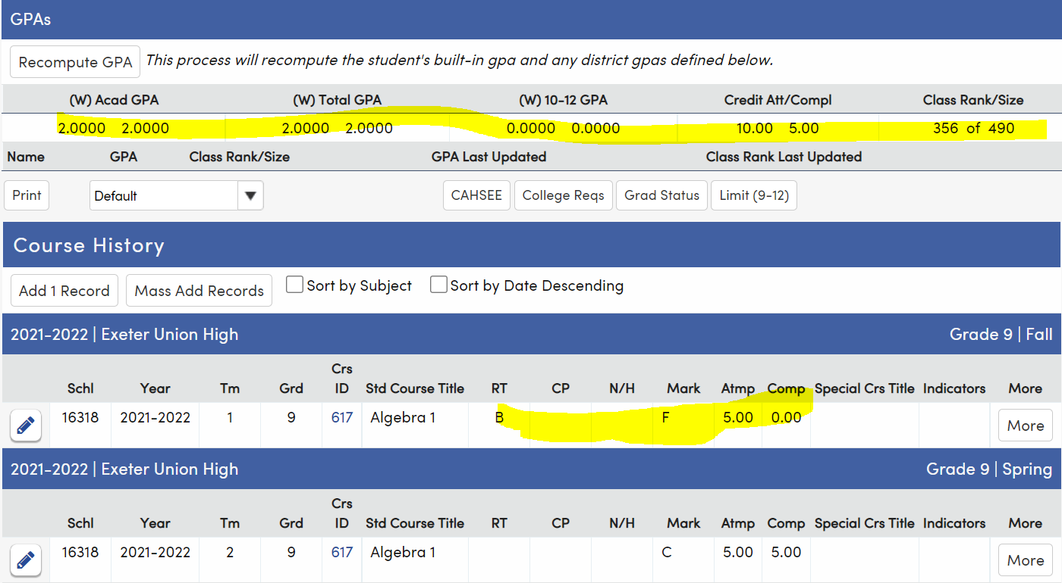

Grad Status – repeat using B on 1st Course
5 Credits of Math Completed
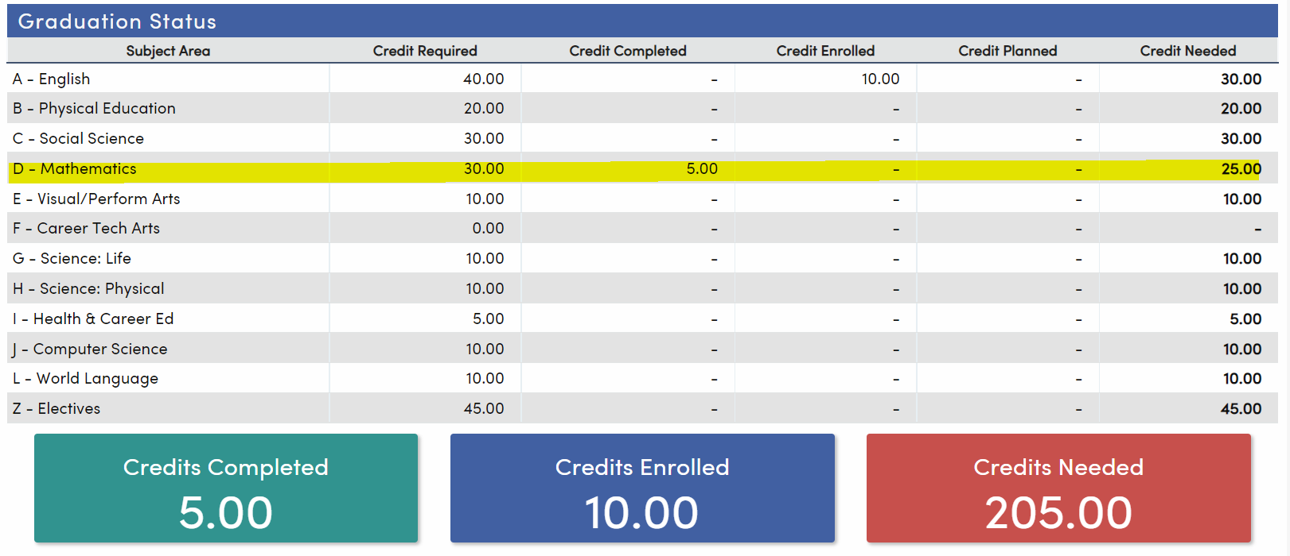

Using Repeat of A - 1st Course- CA, No CC, No GPA
CA = 10, CC = 5, 2.0 GPA
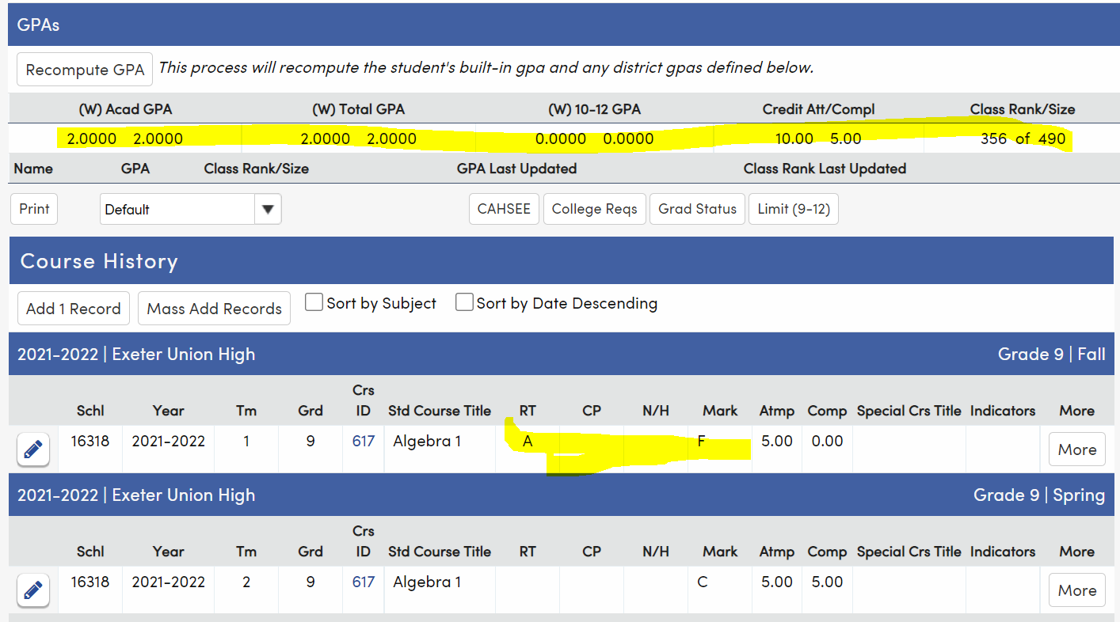

Grad Status – Repeat using A on 1st course - CA, No CC, No GPA
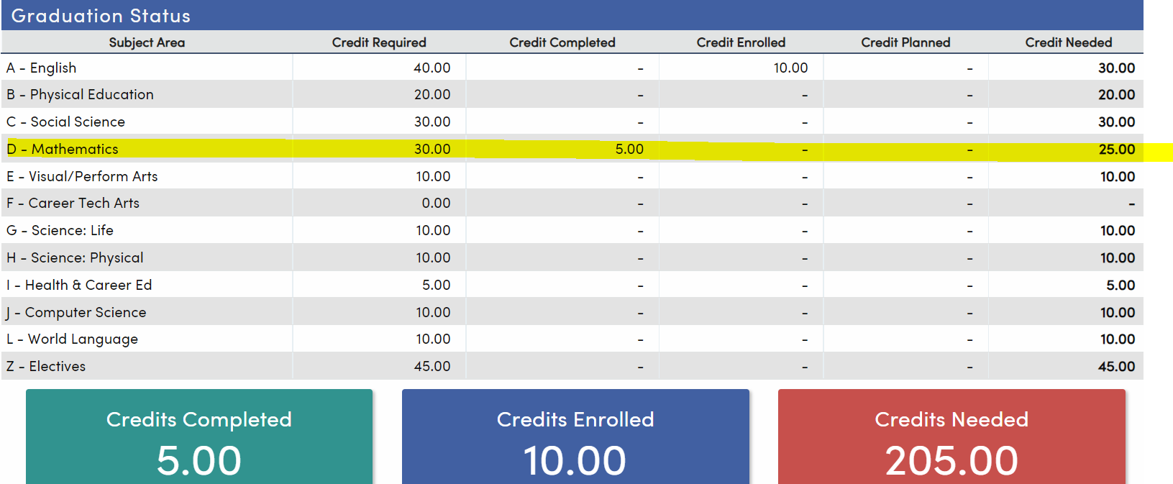

Using Repeat of G – 1st Course – No CA, No CC, GPA
CA = 5, CC = 5, 1.0 GPA
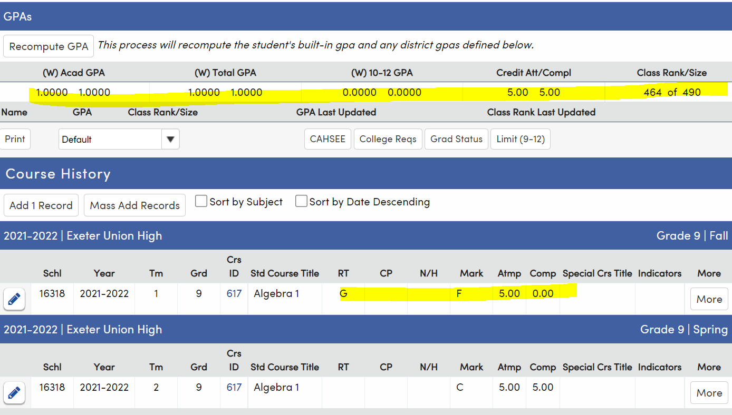

Grad Status - Using Repeat of G – 1st Course – No CA, No CC, GPA
5 Credits of Math completed
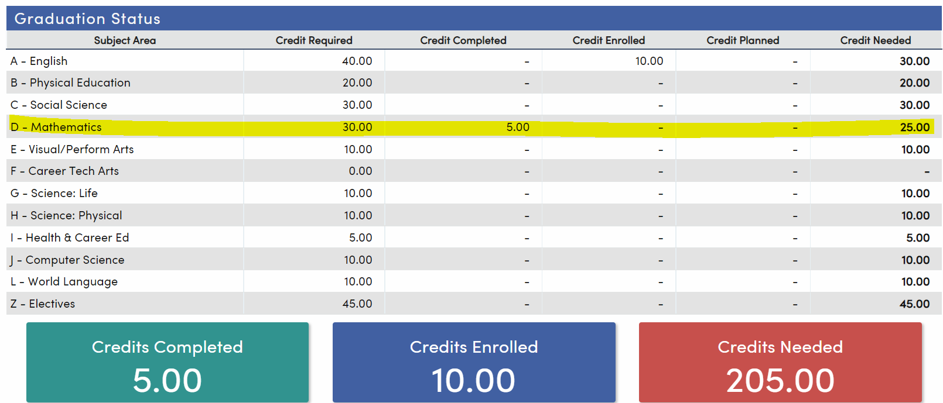

Summary
In general – repeat tags go on the 1st take entry
Exception – student repeats a course and gets a lower mark on the 2nd take.
Repeat tag of R
Most used
Best use is for repeats to improve a mark, not replace a deficiency
Also used for occasions where student received a lower mark on the 2nd take
Repeat tag of N
Essentially removes the mark from any calculation
Repeat tag of B
Removes the mark from the GPA calculation, but counts in CA and CC
Repeat tag of A - Counts in CA but not in CC or GPA
Repeat tag of G – removes from CA and CC, but counts in GPA
Blank – no repeat tag – applies to most entries

