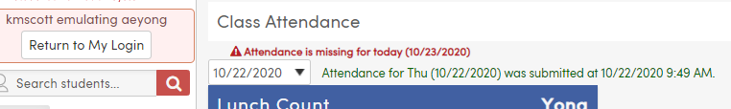

**Teacher has taken attendance, but the ASL log has not been updated.**

